Lab Report

Michael Kim

010572235

5/3/2017

**Program Statement**

The goal of the programming assignment is to make a simple searching program for top 1000 names. To search documents, first the program needs to read file and extract the name. Each name has elements of total counts of corresponding name in US, Percentage and Rank. After extracting information from each name, those names need to be sorted in alphabetical order using Binary Search Tree class. Finally, the program should ask user for name which the user want to search for. If user type QUIT, program should print out whole contents of Binary Tree. The inputs to the program is the ‘last.txt,’ ‘male.txt,’ and ‘female.txt’ file which are given in website.

**Design**

While reading from input txt file, The Name, Count, Percentage, and Rank will be din to each corresponding variable to save at Binary Search Tree. for saving at Binary Search Tree, insertion function will be used. for inserting order, names will be saved in alphabetical order. If the inserting string has bigger letter than what string is in Binary Tree, if goes to right side, if string has smaller letter, than it goes to left side. After completing insertion of binary tree, two function will be used for analyzing Binary Tree. Height function and Count function. Height function will indicate the height of Binary Tree, Count will indicate the total count of elements in Binary Tree. For next, user will be asked for string for searching names in Binary Tree. if the name is found on Tree, corresponding elements of its name should be printed out. if user input ‘QUIT,’ it should print out whole Binary Tree elements in alphabetical order. For last, the user will be asked for another string for deletion. If the name is found of Binary Tree, it should delete the node and link the node properly in right order.

**Implementation**

For Node class, which was used for element of Binary Tree, Four variables were declared for Name, Percentage, Count and Rank. For reading file, while loop was used with din >> name. It stops when it is end of file. Inside of loop, Count, Percentage and Rank was din in order. With four variable, insertion function is used. The insertion and insertion helper function were changed with adding four variables. for InsertHelper, when the NULL Binary Tree is found, adding new node came first. For last, if statement comes next, with comparing string value was written. If the new inserting name string is bigger than the name string that is in Binary Tree, next recursive InsertHelper’s pointer for tree goes to left. If else, it goes to right. For Search function, Node pointer is added in parameter. the Node pointer is for when searching name is found in Binary Tree, to print out corresponding elements. To do so, in SearchHelper, in if statement when the name is found, node from parameter equals to the Tree which is from where it found. in main.cpp, that node pointer is used for printing out. for next, Height and Count function were added. Those functions were used from lab13. For deleting function, string Name was replaced instead of int Value.

**Testing**

- Searching 3 names in file

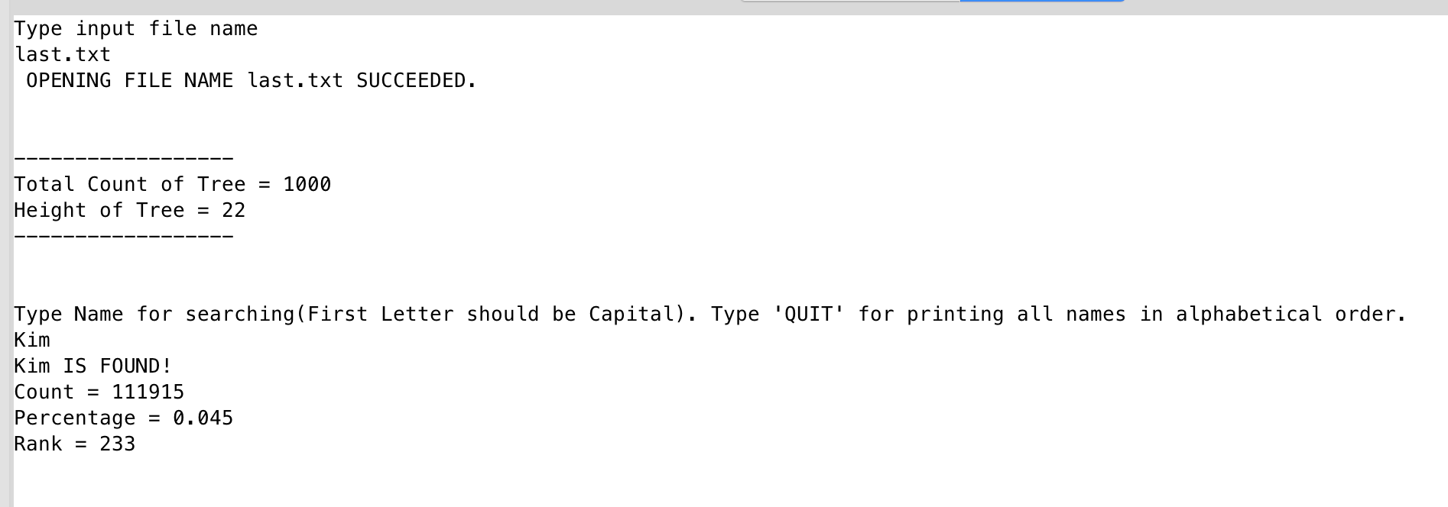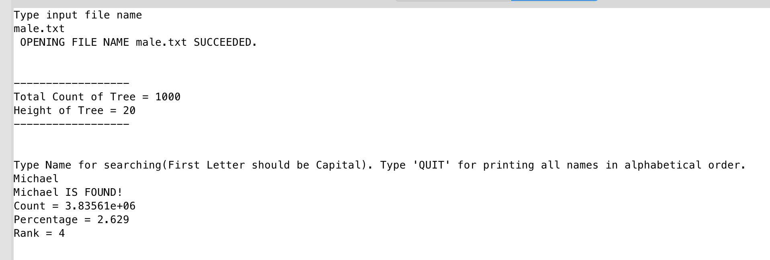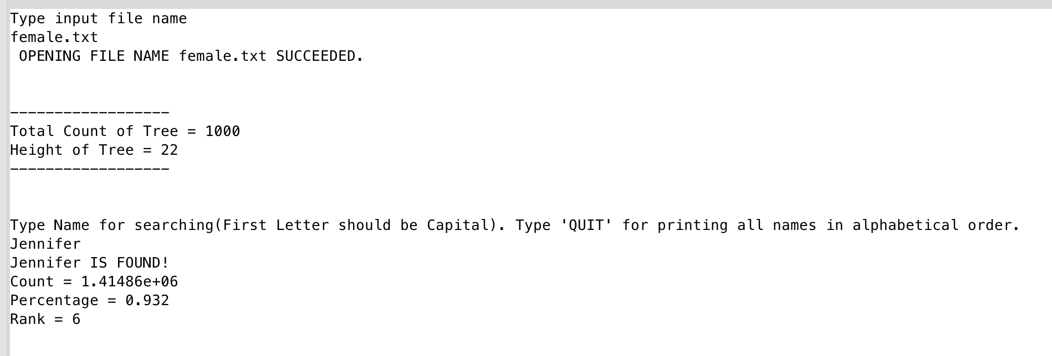

-Searching 3 names Not in file

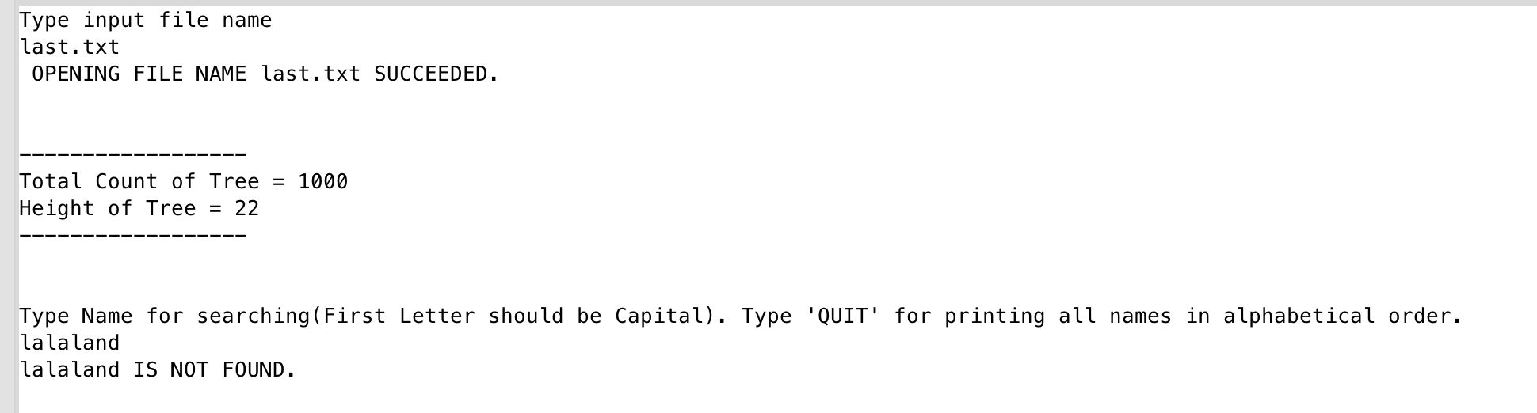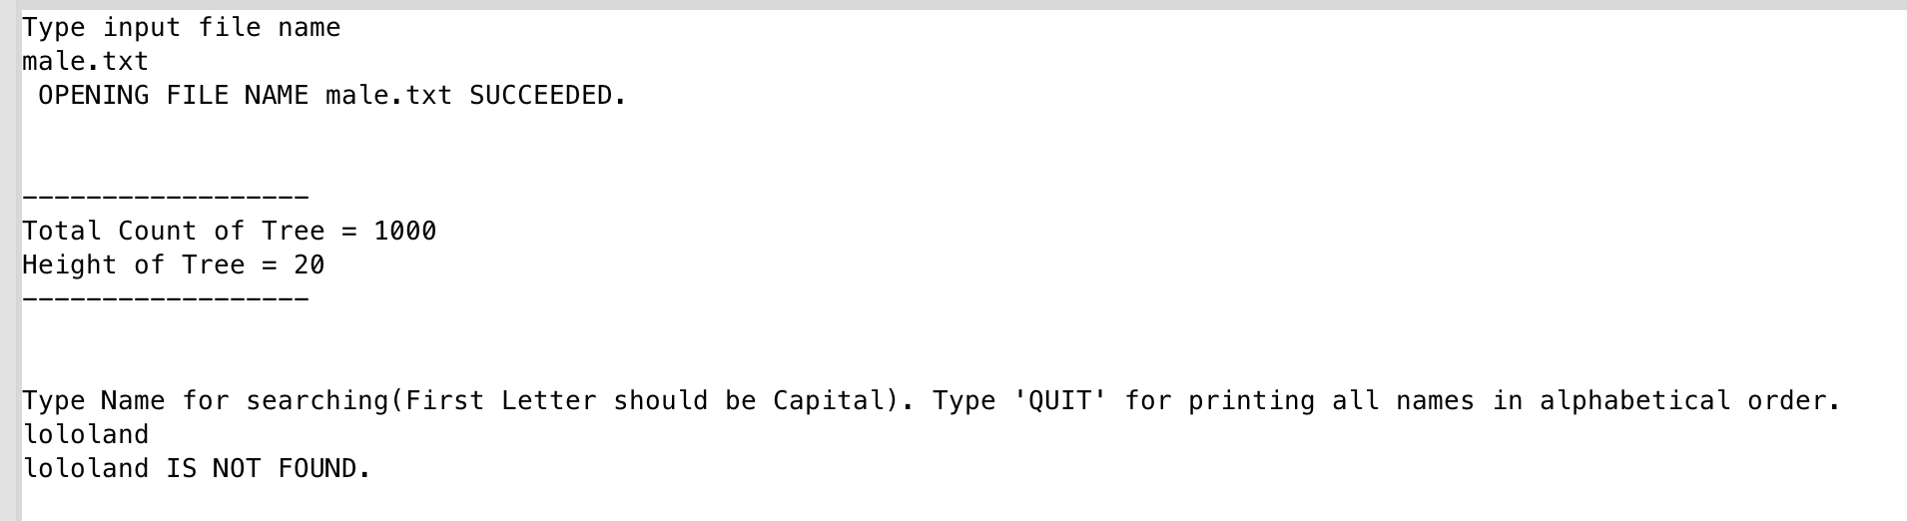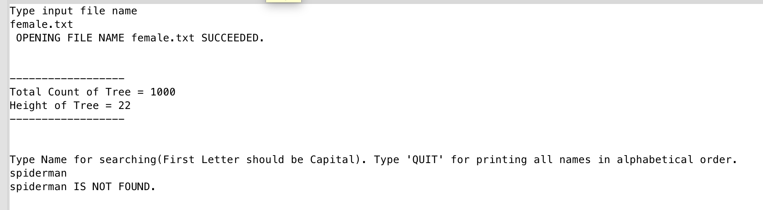

-Typing ‘QUIT’

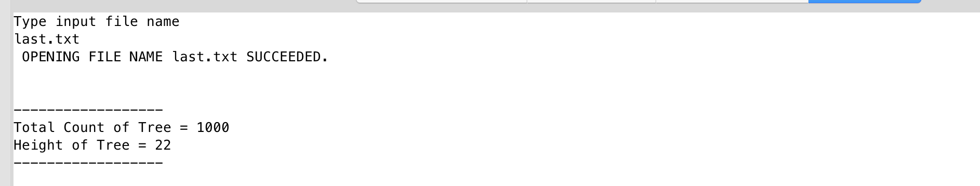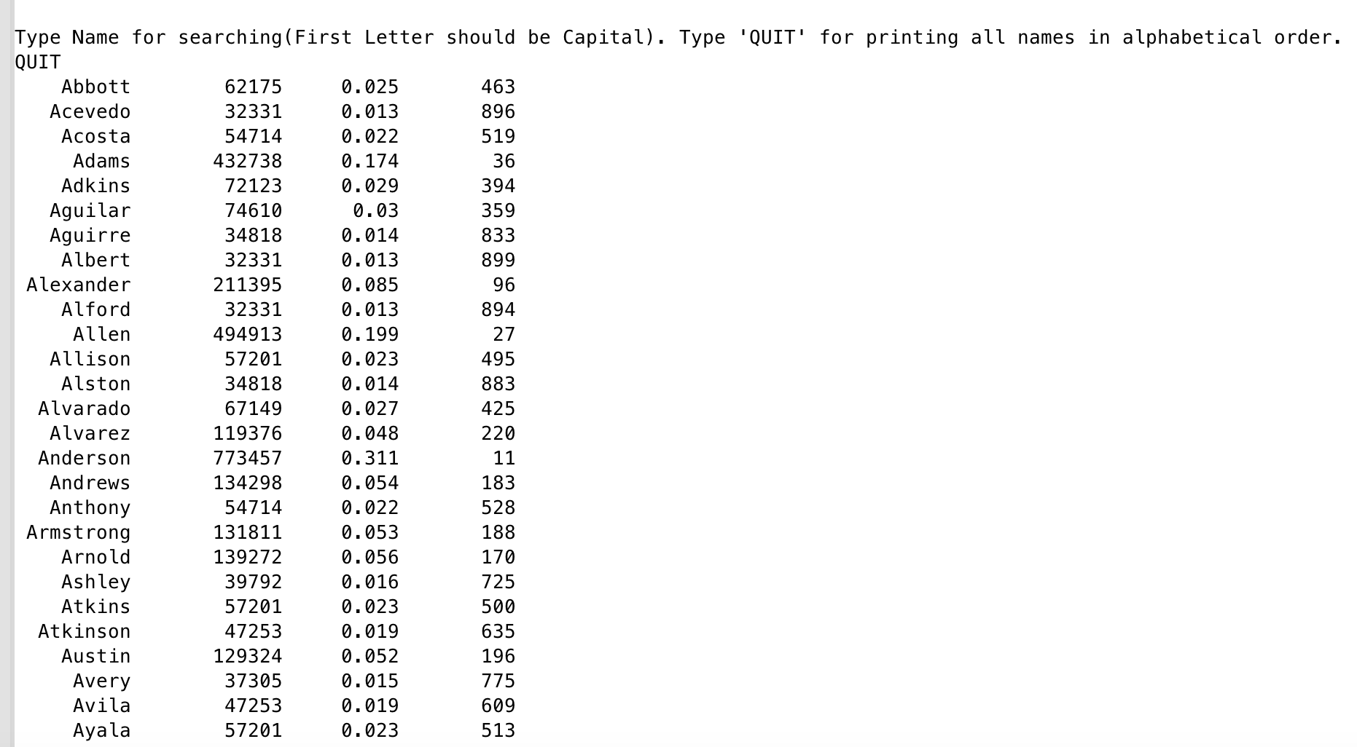

**Conclusion**

The overall result of the assignment came out with correct output with few statements. Project worked successful. I want to try to make this assignment improved that can handle different type of format.